PCA

Principal Component Analysis, or PCA, is a dimensionality-reduction method that is often used to reduce the dimensionality of large data sets, by transforming a large set of variables into a smaller one that still contains most of the information in the large set.

Reducing the number of variables of a data set naturally comes at the expense of accuracy, but the trick in dimensionality reduction is to trade a little accuracy for simplicity. Because smaller data sets are easier to explore and visualize and make analyzing data much easier and faster for machine learning algorithms without extraneous variables to process.

**Step 1: Standardization**

The aim of this step is to standardize the range of the continuous initial variables so that each one of them contributes equally to the analysis.

Mathematically, this can be done by subtracting the mean and dividing by the standard deviation for each value of each variable.

https://cdn-images-1.medium.com/max/1600/0*AgmY9auxftS9BI73.png

Once the standardization is done, all the variables will be transformed to the same scale.

#### Step 2: Covariance Matrix computation

The aim of this step is to understand how the variables of the input data set are varying from the mean with respect to each other, or in other words, to see if there is any relationship between them. Because sometimes, variables are highly correlated in such a way that they contain redundant information. So, in order to identify these correlations, we compute the covariance matrix.

The covariance matrix is a p × psymmetric matrix (where p is the number of dimensions) that has as entries the covariances associated with all possible pairs of the initial variables.

For example, for a 3-dimensional data set with 3 variables x, y, and z, the covariance matrix is a 3×3 matrix of this from:

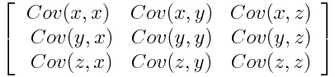

Since the covariance of a variable with itself is its variance (Cov(a,a)=Var(a)), in the main diagonal (Top left to bottom right) we actually have the variances of each initial variable. And since the covariance is commutative (Cov(a,b)=Cov(b,a)), the entries of the covariance matrix are symmetric with respect to the main diagonal, which means that the upper and the lower triangular portions are equal.

It’s actually the sign of the covariance that matters :

* if positive then : the two variables increase or decrease together (correlated)
* if negative then : One increases when the other decreases (Inversely correlated)

cor(X,Y) = \frac{cov(X,Y)}{\sigma _{X}\cdot \sigma_{Y}} 

#### Step 3: Compute the eigenvectors and eigenvalues of the covariance matrix to identify the principal components

Eigenvectors and eigenvalues are the linear algebra concepts that we need to compute from the covariance matrix in order to determine the **principal components** of the data.

Principal components are new variables that are constructed as linear combinations or mixtures of the initial variables. These combinations are done in such a way that the new variables (i.e., principal components) are uncorrelated and most of the information within the initial variables is squeezed or compressed into the first components. So, the idea is 10-dimensional data gives you 10 principal components, but PCA tries to put maximum possible information in the first component, then maximum remaining information in the second and so on, until having something like shown in the scree plot below.

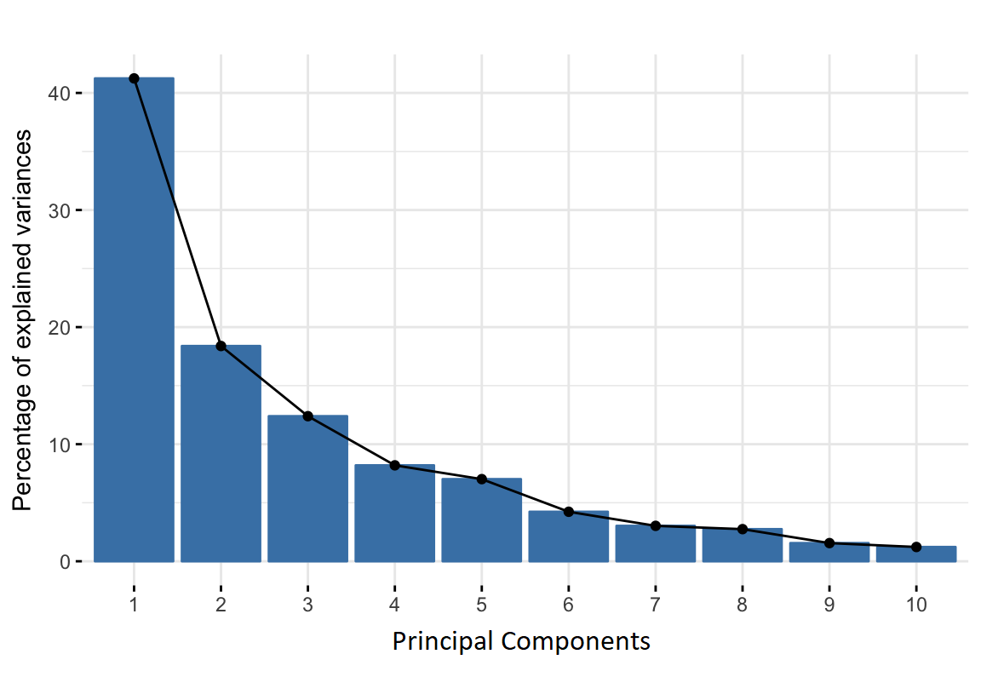

Organizing information in principal components this way, will allow you to reduce dimensionality without losing much information, and this by discarding the components with low information and considering the remaining components as your new variables.

principal components are constructed in such a manner that the first principal component accounts for the **largest possible variance** in the data set.

The second principal component is calculated in the same way, with the condition that it is uncorrelated with (i.e., perpendicular to) the first principal component and that it accounts for the next highest variance.

This continues until a total of p principal components have been calculated, equal to the original number of variables.

it is eigenvectors and eigenvalues who are behind all the magic explained above, because the eigenvectors of the Covariance matrix are thedirections of the axes where there is the most variance (most information) and that we call Principal Components. And eigenvalues are simply the coefficients attached to eigenvectors, which give the amount of variance carried in each Principal Component.

By ranking your eigenvectors in order of their eigenvalues, highest to lowest, you get the principal components in order of significance.

#### Step 4: Feature vector

As we saw in the previous step, computing the eigenvectors and ordering them by their eigenvalues in descending order, allow us to find the principal components in order of significance. In this step, what we do is, to choose whether to keep all these components or discard those of lesser significance (of low eigenvalues), and form with the remaining ones a matrix of vectors that we call Feature vector.

#### Step 5 : Recast the data along the principal components axes

This step aim is to use the feature vector formed using the eigenvectors of the covariance matrix, to reorient the data from the original axes to the ones represented by the principal components

This can be done by multiplying the transpose of the original data set by the transpose of the feature vector.

https://cdn-images-1.medium.com/max/1600/0*D02r0HjB8WtCq3Cj.png